STARTUP FUND ANALYSIS   
  
Presentation: The startup industry is developing step by step, it is particularly expanding step by step.   
  
It's extremely critical to think about how the development of new businesses is whether it's expanding of diminishing.   
  
It is mandatory to keep up the correct record and examination of that is required with the assistance of AI calculations we can likewise foresee the misfortunes of the organization just as the odds of the best possible development in the business. Machine learning calculations can help in the characterization of the information on the bases of the parameters like speculation and what kind of sells or product progress is there in the market.

DATASET:

F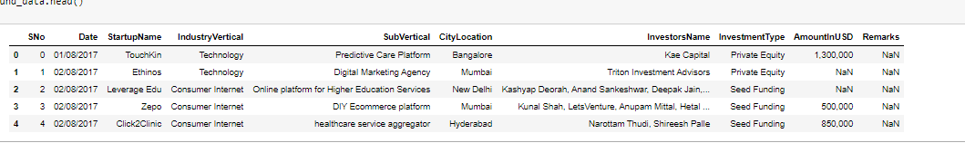ig: Dataset available on open source platform

Images of Analysis data set:

Here we can find out about the funding related information.

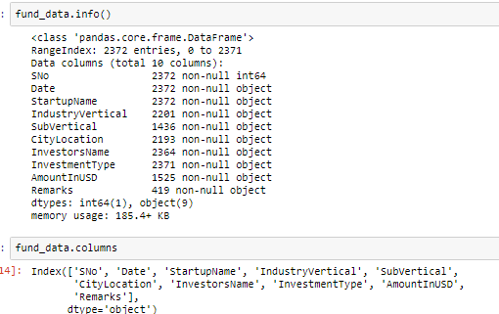

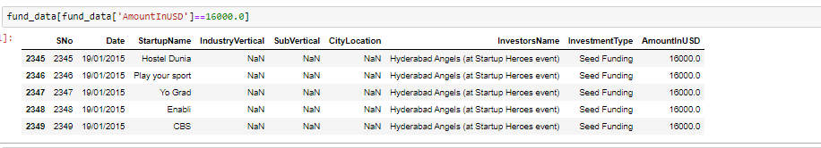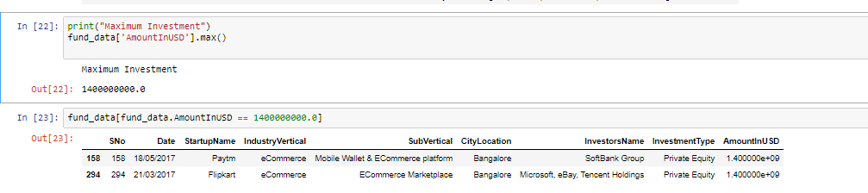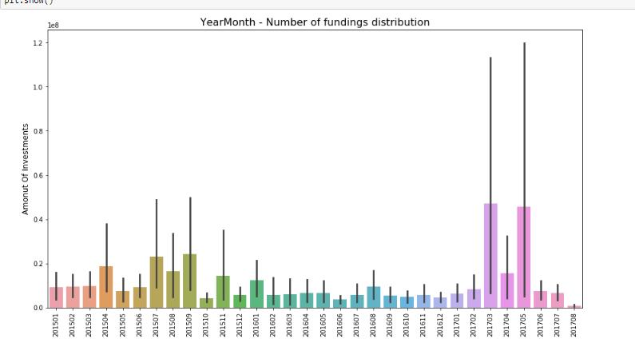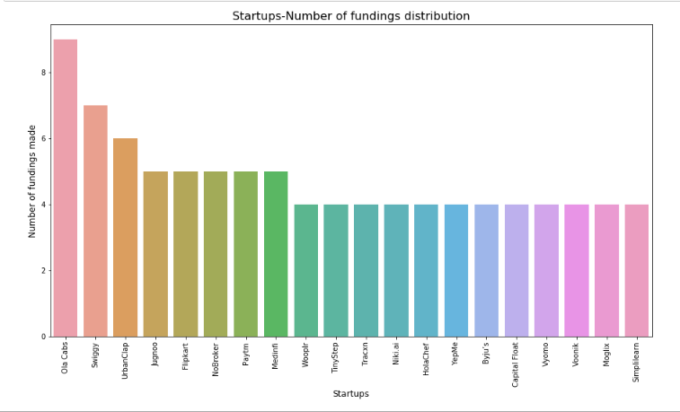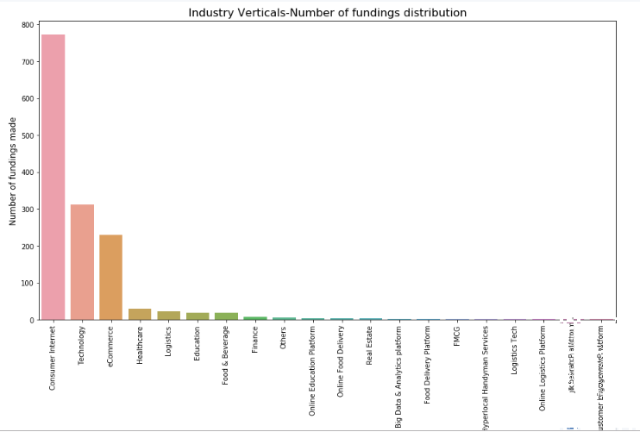

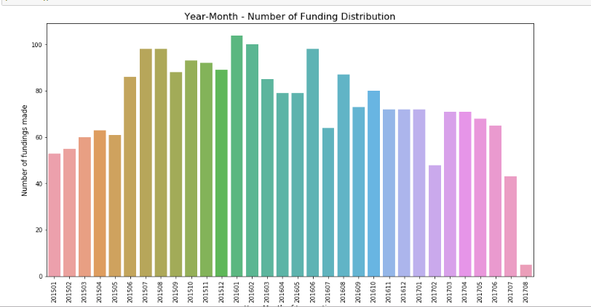

Conclusion : It extremely simple for the examination of the business-related issue with the assistance of AI. Here, for this situation, we can investigate the development and the assets' apportion got by the organization.